Dataset3= emp_details_2:

[

{

"id":"101",

"name":"srinivas",

"gender":"male"

},

{

"id":"102",

"name":"phani",

"gender":"male"

}

]

Do exactly same as previous one

Go to projection-> import projection->you will know columns in dataset

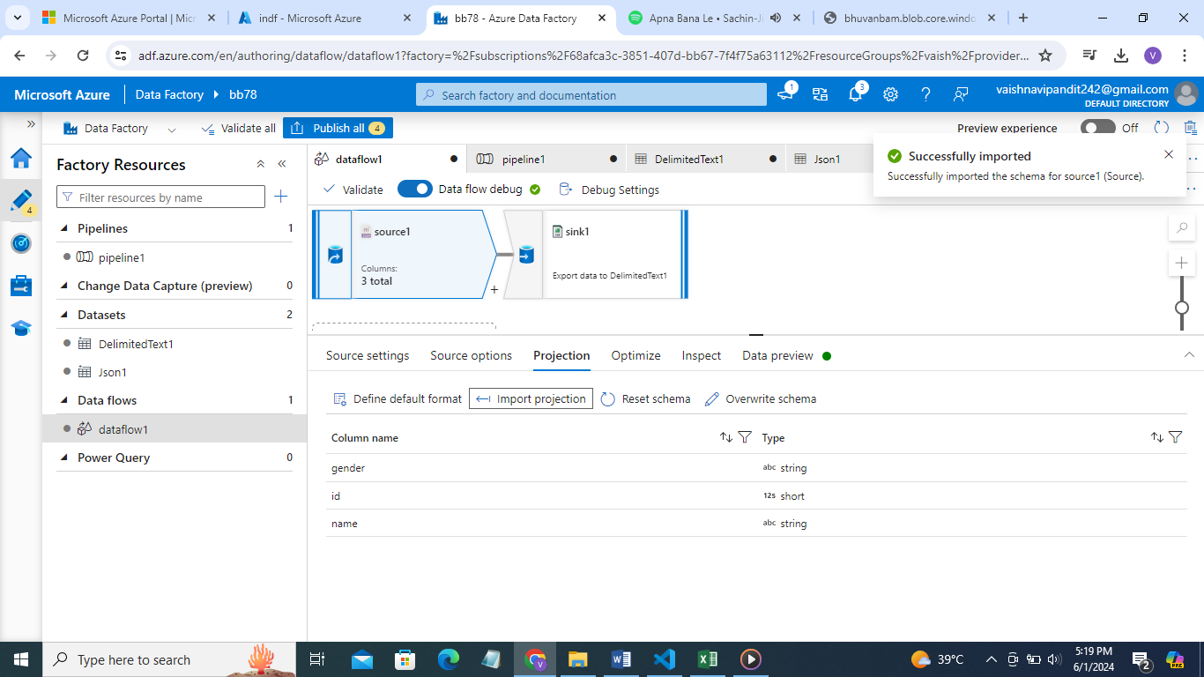

Do this if you change the dataset but in same source that used previously otherwise preview will show the columns of the previous datasets also and its values will be null

Go see preview

